### [**Red Pickup Truck with a Christmas Tree**](https://papercraftetc.blogspot.com/2018/12/red-pickup-truck-with-christmas-tree.html)

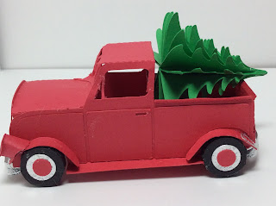

This red pickup truck looks beautiful with a Christmas tree. I used card stock and silver wrapping paper to make this model. I recommend gluing the model slowly tab by tab.

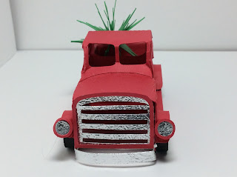

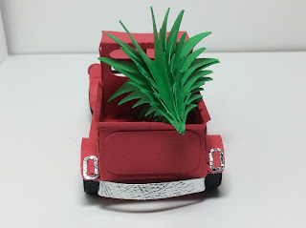



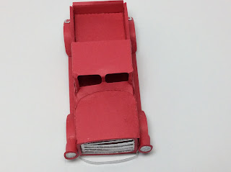

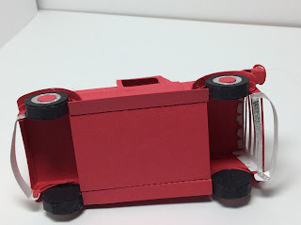

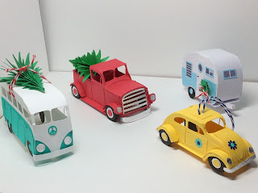

My fleet of vehicles is expanding.